Lab 1

Title:
To create a CV using common HTML elements using table layout

1. Objective:
The objective of this lab work is to design and develop a simple Curriculum Vitae (CV) using basic HTML elements. This lab focuses on using the HTML <table> layout to organize personal information, educational background, skills, and other details in a structured format.

2. Tools / Software Used:
- Operating System: Windows / Linux / macOS
- Text Editor: VS Code / Notepad++ / Notepad
- Web Browser: Google Chrome / Mozilla Firefox

3. Theory:
HTML (HyperText Markup Language) is the standard language used to create web pages. It uses different tags to structure content such as text, images, links, and tables.
In this lab, the <table> element is used to create a structured layout for the CV. Tables consist of rows (<tr>), table headers (<th>), and table data cells (<td>). Common HTML elements like headings (<h1>), paragraphs (<p>), lists (<ul>), and horizontal lines (<hr>) are also used to enhance readability and organization.
Using table layout helps in aligning content neatly, especially for beginner-level HTML designs.

4. Algorithm / Procedure:
- Start a new HTML file.
- Define the basic HTML structure using <html>, <head>, and <body> tags.
- Add a title for the CV page.
- Create a main table to hold CV information.
- Use table rows and columns to organize personal details, education, skills, and experience.
- Insert headings and text inside table cells.
- Save the file with .html extension.
- Open the file in a web browser to view the output.

5. Source Code:

<html>
<head>
<title>Curriculum Vitae</title>
</head>

<body>
<h1 align="center">Curriculum Vitae</h1>
<hr>
<table border="1" width="30%" align="center" cellpadding="5" cellspacing="0">
<tr>
<td colspan="3">
<h3>
<center>Personal Information</center>
</h3>
</td>
</tr>
<tr>
<td><b>Name</b></td>
<td>Mahesh Udas</td>
<td rowspan="4">
<img src="me.jpg" alt="Profile Photo" width="120" height="135">
</td>
</tr>
<tr>
<td><b>Email</b></td>
<td>maheshudas2077@gmail.com</td>
</tr>
<tr>
<td><b>Phone</b></td>
<td>9806871409</td>
</tr>
<tr>
<td><b>Address</b></td>
<td>Pokhara, Nepal</td>
</tr>
<tr>
<td colspan="3">
<h3>Educational Qualification</h3>
<table border="1" cellpadding="2" cellspacing="0" width="100%">
<tr>
<th>Level</th>
<th>Institution</th>
</tr>
<tr>
<td>Bachelor</td>
<td>Tribhuvan University</td>
</tr>
<tr>
<td>+2</td>
<td>Birgunj College</td>
</tr>
</table>
</td>
</tr>
<tr>
<td colspan="3">
<h3>Skills</h3>
<ul>
<li>HTML, CSS, JavaScript</li>
<li>C/C++/PHP/Python/JAVA Programming Languages</li>
<li>ReactJS/NsxtJS/NodeJS</li>
<li>MySql/JSON</li>
</ul>
</td>
</tr>
<tr>
<td colspan="3">
<h3>Experience</h3>
<p>A passionate full stack developer skilled in React, Node.js, Tailwind CSS, and more. I love building
modern, scalable apps that solve real-world problems.</p>
</td>
</tr>
</table>
</body>

</html>

6. Output:

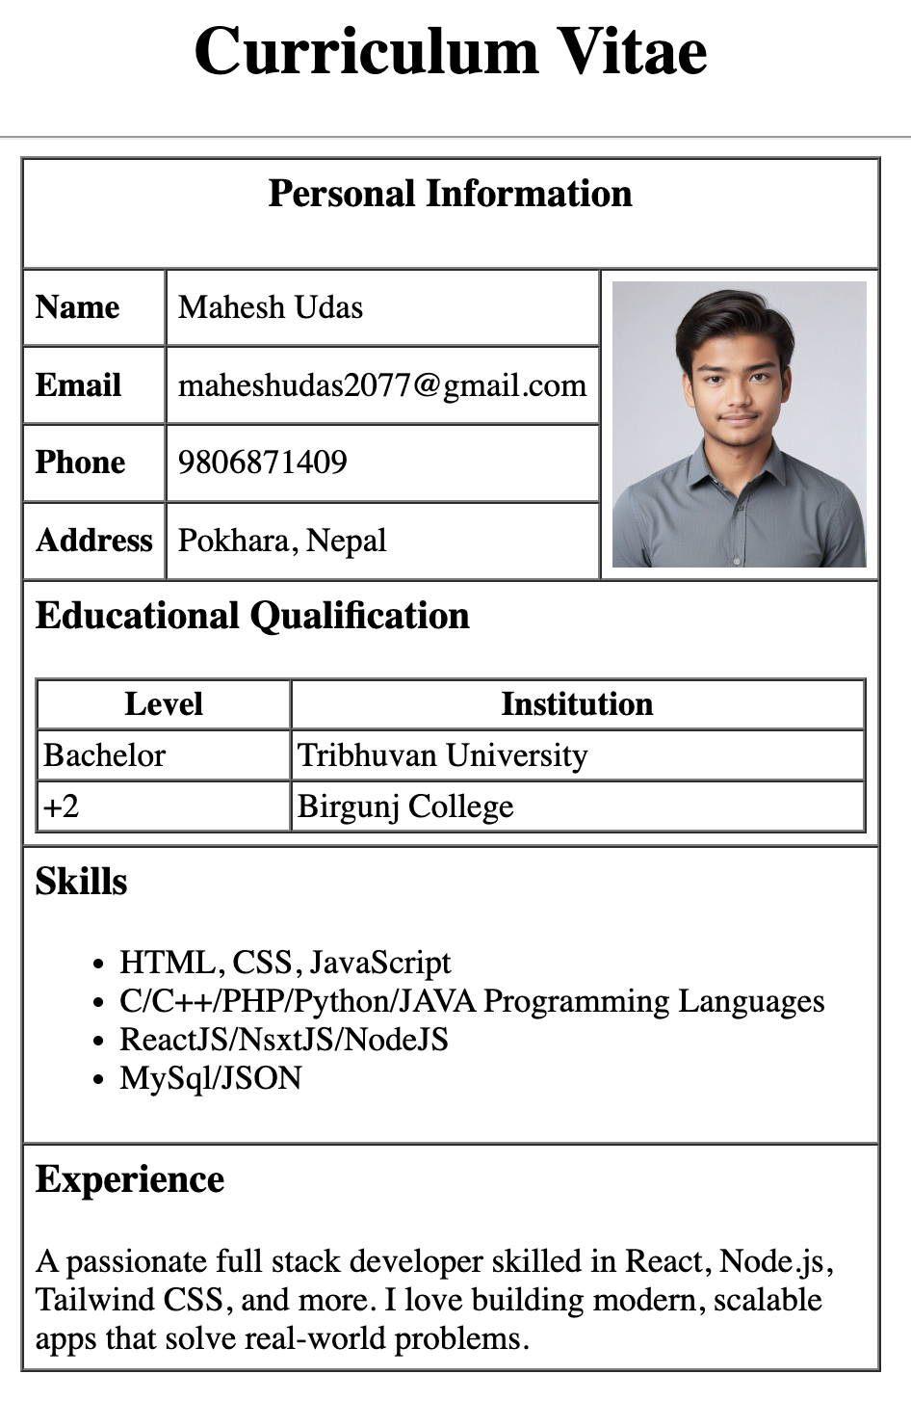

7. Conclusion:
In this lab work, a simple CV was successfully created using basic HTML elements and table layout. This experiment helped in understanding the structure of HTML documents and the practical use of tables to organize content effectively. It also strengthened basic skills in writing and viewing HTML code in a web browser.

I have to print below pages……

5. Source Code:

<html>
<head>
<title>Curriculum Vitae</title>
</head>

<body>
<h1 align="center">Curriculum Vitae</h1>
<hr>
<table border="1" width="30%" align="center" cellpadding="5" cellspacing="0">
<tr>
<td colspan="3">
<h3>
<center>Personal Information</center>
</h3>
</td>
</tr>
<tr>
<td><b>Name</b></td>
<td>Mahesh Udas</td>
<td rowspan="4">
<img src="me.jpg" alt="Profile Photo" width="120" height="135">
</td>
</tr>
<tr>
<td><b>Email</b></td>
<td>maheshudas2077@gmail.com</td>
</tr>
<tr>
<td><b>Phone</b></td>
<td>9806871409</td>
</tr>
<tr>
<td><b>Address</b></td>
<td>Pokhara, Nepal</td>
</tr>
<tr>
<td colspan="3">
<h3>Educational Qualification</h3>
<table border="1" cellpadding="2" cellspacing="0" width="100%">
<tr>
<th>Level</th>
<th>Institution</th>
</tr>
<tr>
<td>Bachelor</td>
<td>Tribhuvan University</td>
</tr>
<tr>
<td>+2</td>
<td>Birgunj College</td>
</tr>
</table>
</td>
</tr>
<tr>
<td colspan="3">
<h3>Skills</h3>
<ul>
<li>HTML, CSS, JavaScript</li>
<li>C/C++/PHP/Python/JAVA Programming Languages</li>
<li>ReactJS/NsxtJS/NodeJS</li>
<li>MySql/JSON</li>
</ul>
</td>
</tr>
<tr>
<td colspan="3">
<h3>Experience</h3>
<p>A passionate full stack developer skilled in React, Node.js, Tailwind CSS, and more. I love building
modern, scalable apps that solve real-world problems.</p>
</td>
</tr>
</table>
</body>

</html>

6. Output:



7. Conclusion:

